## 1. Project Cover Page

Dope Spot

Project Initiation Document (PID)

## 2. Document History

* Created by: Anghel Stefan
* Approved by: -
* Document Status: Completed
* Document Version: 1.0
* Revision History:
  + 2024-03-15: Document creation by Anghel Stefan (Version 0.1)
  + 2024-04-03: Paragrapher 9 and 10, Appendix 1 and 2, E-R chart and Logical Scheme (Version 0.2)
  + 2024-05-09: Paragrapher 11 and 12, Appendix 3,4 and 5 (Version 0.3)
  + 2024-05-16: Paragrapher 13, Appendix 6,(Version 0.4)
  + 2024-05-22: Complete the other paragrapher(1-6)(Version 0.5)
  + 2024-05-23: Deliver the document. (Version 1.0)

## 3. Summary

**Page 4** Introduction

**Page 4** Purpose of the Document

**Page 4** Project Approach

**Page 5** Project Phases

**Page 6** Project Definition

**Page 6** Organization of the Project

**Page 7** Roles and Responsibilities

**Page 7** Standards

**Page 11** Quality Control

**Page 16** Risks and Assumptions

**Page 19** WBS

Project Management Appendices: Detailed Explanations

**Page 22** Appendix 1: Project Roles and Responsibilities

**Page 23** Appendix 2: High-Level Project Plan

**Page 24** Appendix 3:Gantt and Pert

**Page 25** Appendix 4: Project Costs

**Page 25** Appendix 5: gap analysis

**Page 27** Appendix 6: Product Software Evaluation

## 4. Introduction

* "Dope Spot" isn't just another online clothing store – it's a destination for those who seek to express themselves through their style. Our mission is simple yet profound: to provide a carefully curated selection of streetwear and vintage clothing that speaks to the heart of urban culture. From bold, eye-catching designs to timeless classics, we believe in offering our customers a diverse range of options to suit their individual tastes and preferences.

## 5. Purpose of the Document

* The purpose of this document is to provide a comprehensive overview of "Dope Spot," including its objectives, scope of intervention, activity plan, management structure, usage guidelines, and document review procedures. By detailing these aspects, the document aims to facilitate a clear understanding of the project's goals and operations.
* The project plan contained in this document includes all the elements necessary for effective planning. Planning involves developing a work plan that describes how to achieve the set objectives for our solution. It is essential that the document is easily readable and flexible to accommodate new changes that may occur throughout the project's duration. This planning document was created in the initial phase and will be updated in all subsequent phases of the project, detailed in point 6.
* Document revisions will be described in the "Document History" (Point 2), the section of the project plan where the document's history is recorded. It is important that project plan revisions are always reviewed and accepted by the program committee.

## 6. Project Approach

* The "Dope Spot" project requires a structured methodological approach for its development and management. It is essential to use modern technologies like Vue.js and Tailwind CSS to optimize user experience and ensure seamless navigation. Additionally, Laravel will be employed for database management and security, ensuring data protection and integrity.
* The necessary activities for project completion will be detailed in the Work Breakdown Structure (WBS), breaking down the work into specific tasks and describing the type of work to be performed. A Gantt chart will be used to manage the project timeline, monitoring the duration of each activity and phase for their completion. A Pert diagram will also be necessary to graphically describe the dependencies between various activities and to develop the Critical Minimum Path (CMP), which indicates the minimum duration of the project and identifies critical activities. These critical activities, if delayed even by a single day, could delay the entire project.
* Costs will be managed through a preliminary budget, detailing the expenses required for each activity. It is crucial to maintain uniform costs across the various phases of the project to avoid the risk of failure due to excessive concentration of funds on a single phase.

## 7. Project Phases

* Define each phase with key deliverables and timelines:
  + Planning: Establish project boundaries, deliverables, and objectives.
  + Project Design: Research customer preferences, market trends, and competitors.
  + Realization:
    - Develop the online platform for the clothing store.
    - Include tasks like domain registration, design, frontend/backend development, and e-commerce functionality.
  + Deployment: Manage inventory, create product catalogs, organize product photography and descriptions.
  + Launch: Officially introduce Dope Spot to the public through planned strategies.

## 8. Project Definition

**8.1 Project Objectives**

* Establish an innovative online clothing store for urban culture with trendy and vintage apparel.
* Provide customers with a seamless and satisfying online shopping experience.

**8.2 Scope and Intervention Areas**

* Develop and launch the online clothing store, including website design, product catalog creation, backend development, marketing strategies, and legal compliance.
* Intervention areas include market analysis, website development, product management, marketing, and promotion.

**8.3 Project Results or Deliverables**

* A fully functional and visually appealing online clothing store.
* A diverse product catalog featuring both trendy and vintage apparel.
* A user-friendly shopping experience with intuitive navigation and secure payment options.
* Enhanced brand visibility and customer engagement through marketing and promotion.
* Adherence to legal and regulatory standards through terms and conditions and privacy policies.

## 9. Organization of the Project

## 

## 

## 

## 

## 

## 

## 

## 10. Roles and Responsibilities

* **Program Board:** Oversees the entire program and ensures all projects are aligned with the program’s goals.
* **Sponsor:** Provides financial backing and champions the program within the organization.
* **Quality Manager:** Ensures that the project meets the quality standards.
* **Project Manager:** Oversees and coordinates the project, ensuring it is delivered on time, within budget, and meets the project goals.
* **Administration Manager:** Provides administrative support to the program or project team.
* **Team Leader:** Leads a team of developers or designers.
* **Marketing Manager:** Develops and executes marketing campaigns to promote the project.
* **Stakeholder:** An individual or group with an interest in the project.
* **External Provider:** A company or individual that provides goods or services to the project team.
* **Project Designer:** Creates visual aids and other documentation to communicate the project plan.
* **Graphic Designer:** Creates graphic design elements for the project.
* **Analyst:** Analyzes data and provides insights to the project team.
* **Product Manager:** Drives the strategy and development of a product or product line within the project.
* **Frontend Developer:** Develops the front-end (user-facing) side of a website or application.
* **Specialist Technician:** A technician with specialized skills relevant to the project.
* **Backend Developer:** Develops the back-end (server-side) logic and functionality of a website or application.

## 11. Standards

**Prevent Cyber Threats**

* ISO/IEC 27001: This international standard specifies the requirements for establishing, implementing, maintaining, and continually improving an information security management system (ISMS). The goal is to help organizations protect their information assets through a systematic approach to managing sensitive company information so that it remains secure. It includes people, processes, and IT systems by applying a risk management process. ISO/IEC 27001 is essential for protecting sensitive data against unauthorized access, ensuring confidentiality, integrity, and availability of information.
* ISO/IEC 27002: This standard provides detailed guidelines to assist in implementing the controls listed in ISO/IEC 27001. It offers best practices for information security management, including access control, encryption, human resource security, and incident response. By following ISO/IEC 27002, organizations can ensure they meet the necessary security requirements and effectively manage risks to information security.
* OWASP (Open Web Application Security Project): OWASP is an online community dedicated to improving the security of software. It provides freely available articles, methodologies, documentation, tools, and technologies in various fields, including web security. OWASP is known for its top ten list of the most critical web application security risks, which helps organizations identify and mitigate common vulnerabilities in their web applications.
* ISO/IEC 15408 (Common Criteria): This international standard is used for evaluating the security properties of IT products and systems. Common Criteria (CC) provides a framework for defining the security requirements for a product and evaluating the product against those requirements. The evaluation process ensures that the product's security features are tested and verified, providing assurance to users that the product meets the specified security standards.
* ETSI EN 303 645: This standard specifies cybersecurity provisions for consumer Internet of Things (IoT) devices. It establishes a set of baseline requirements to ensure that IoT devices are secure by design, protecting against the most common vulnerabilities and attacks. The standard covers aspects such as data protection, software updates, and secure communications.

**Data Protection and Privacy**

* GDPR (General Data Protection Regulation): GDPR is a European Union regulation that came into effect in 2018. It sets strict rules on the collection, processing, and storage of personal data, ensuring that organizations handle personal data transparently, securely, and legally. GDPR gives EU citizens greater control over their personal data, including rights to access, correct, and delete their information. Non-compliance with GDPR can result in severe penalties, making it crucial for organizations to adhere to these regulations to protect individual privacy rights.

**Web Security**

* HTTP Strict Transport Security (HSTS): HSTS is a security policy mechanism that helps to protect websites against certain types of attacks, such as man-in-the-middle attacks and cookie hijacking. By enforcing the use of HTTPS, HSTS ensures that browsers only communicate with websites over secure connections, preventing users from accidentally visiting insecure HTTP versions of the site.
* WCAG (Web Content Accessibility Guidelines): Developed by the World Wide Web Consortium (W3C), WCAG provides guidelines to make web content more accessible to people with disabilities. These guidelines cover a wide range of recommendations to improve the accessibility of web content, including aspects like text alternatives for non-text content, adaptable content, distinguishable content, and input assistance. Adhering to WCAG ensures that websites are usable by a broader audience, including individuals with visual, auditory, motor, and cognitive disabilities.
* ARIA (Accessible Rich Internet Applications): ARIA is a W3C specification that provides a set of attributes to make web applications more accessible to people with disabilities. ARIA enhances the accessibility of dynamic content and complex user interface controls developed with HTML, JavaScript, and related technologies. It helps developers create more accessible web applications by providing additional information to assistive technologies.
* ISO/IEC 25010: This international standard defines a set of software quality characteristics and metrics. The quality model described in ISO/IEC 25010 includes characteristics such as functionality, reliability, usability, efficiency, maintainability, and portability. This standard provides a comprehensive framework for evaluating and ensuring the quality of software products, helping organizations develop high-quality software that meets user needs and expectations.
* CSP (Content Security Policy): CSP is a security standard designed to prevent cross-site scripting (XSS), clickjacking, and other code injection attacks resulting from the execution of malicious content in the context of a trusted web page. CSP allows web developers to control resources that can be loaded and executed on their web pages, thereby reducing the risk of vulnerabilities being exploited by attackers.

**Technical Standards**

* W3C (World Wide Web Consortium): The W3C is an international community that develops open standards to ensure the long-term growth of the Web. It is responsible for creating and maintaining technical specifications for HTML, CSS, XML, HTTP, and other foundational web technologies. The goal of W3C is to ensure web interoperability and accessibility, making the Web accessible to all users, regardless of their devices or abilities.
* IETF (Internet Engineering Task Force): The IETF is an open standards organization that develops and promotes voluntary Internet standards, particularly the standards that comprise the Internet protocol suite (TCP/IP). The IETF is responsible for defining protocols and best practices that ensure the smooth operation and evolution of the Internet. Standards developed by the IETF cover a wide range of technologies, including IP addressing, routing, email, and security protocols.

**Process Standards**

* **ISO 9001:** Itis a quality management standard focusing on organizational processes, ensuring that the quality of products and services consistently meets customer requirements. By implementing ISO 9001, you can establish clear quality objectives, define procedures for quality control and assurance, and promote continuous improvement.
* ISO 25000: It is a standard for software quality requirements and evaluation (SQuaRE), providing a comprehensive framework for defining, evaluating, and managing the quality of software products and systems. By following ISO 25000 guidelines, you can ensure that your software products meet functional, performance, and usability requirements.

## 12. Quality Control

Logical Scheme

* **Categories**(**id**,name)
* **Product** **Images**(**id**,product_id*,images)
* **Brands**(**id**,name)
* **Product** **Types**(**id**,name)
* **Products**(**id**,category_id*,brand_id*, product_type_id*,name,description,price)
* **Product**_**Variations**(**id**,product_id*,size,color,quantity)
* **Credit**_**Cards**(**id**,user_id*,card_number,expiration_date,cvv)
* **Orders**(**id,**user_id*,order_date,status,credit_card_id*,total_price)
* **Order**_**Items**(**id,**order_id*,product_variation_id*,quantity,price)
* **Carts**(**id**,user_id*)
* **Cart**_**Items**(**id**,cart_id*,product_variation_id*,quantity,price)
* **Users**(**id**,name,email,password,telephone,address,city,postal_code,state,google_id)

E-R Chart

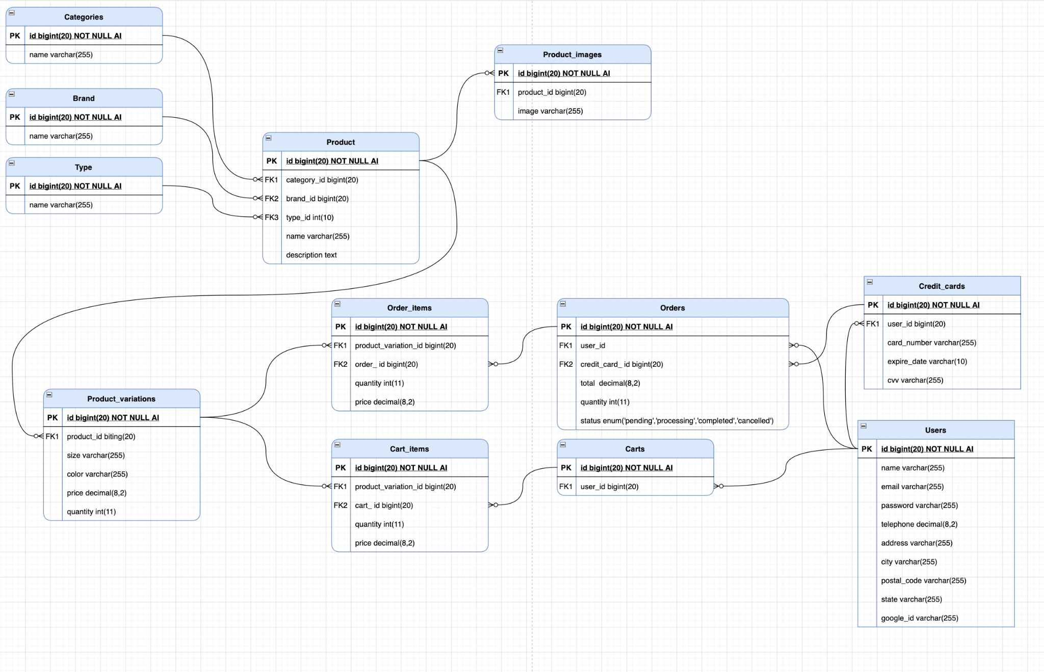

**Login and Register**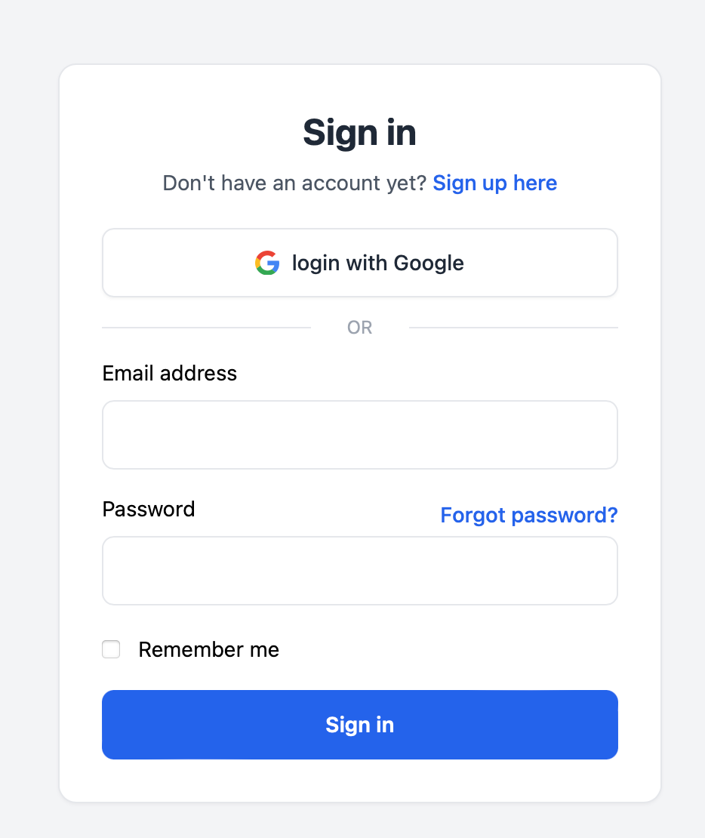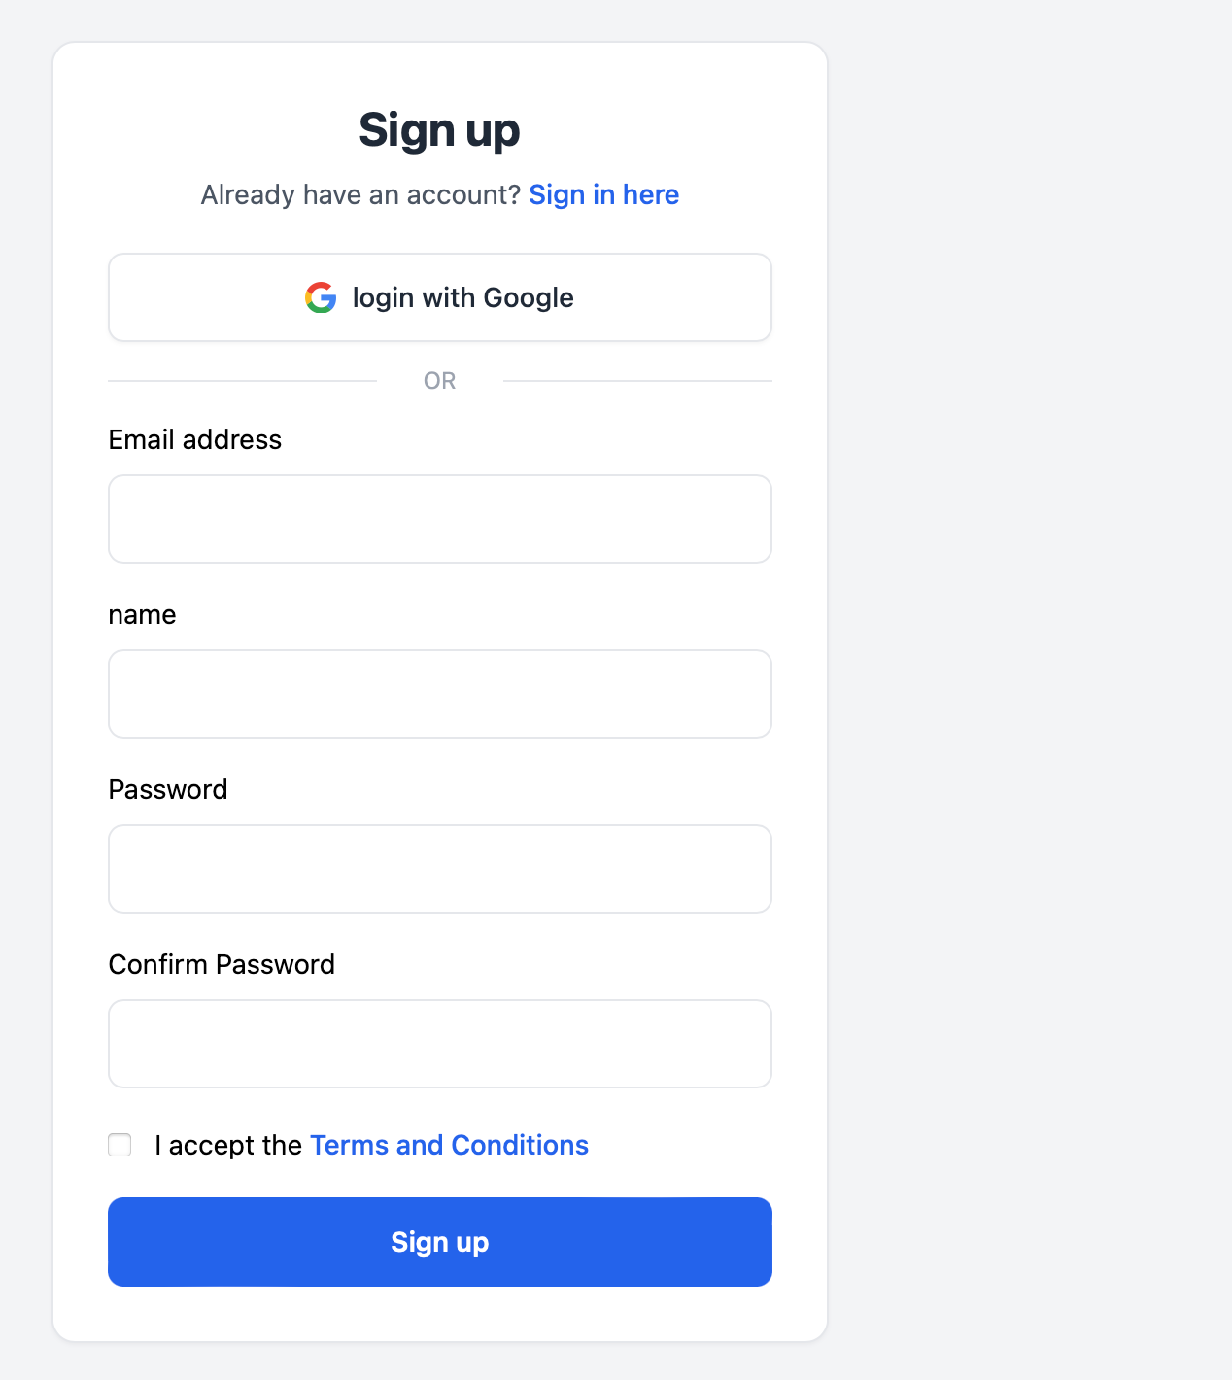

**Responsive home**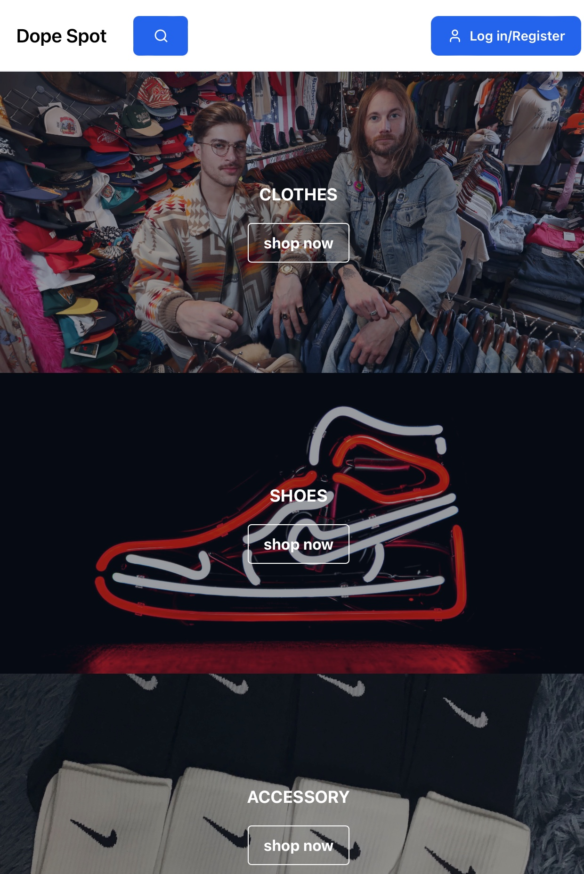

**Responsive page product**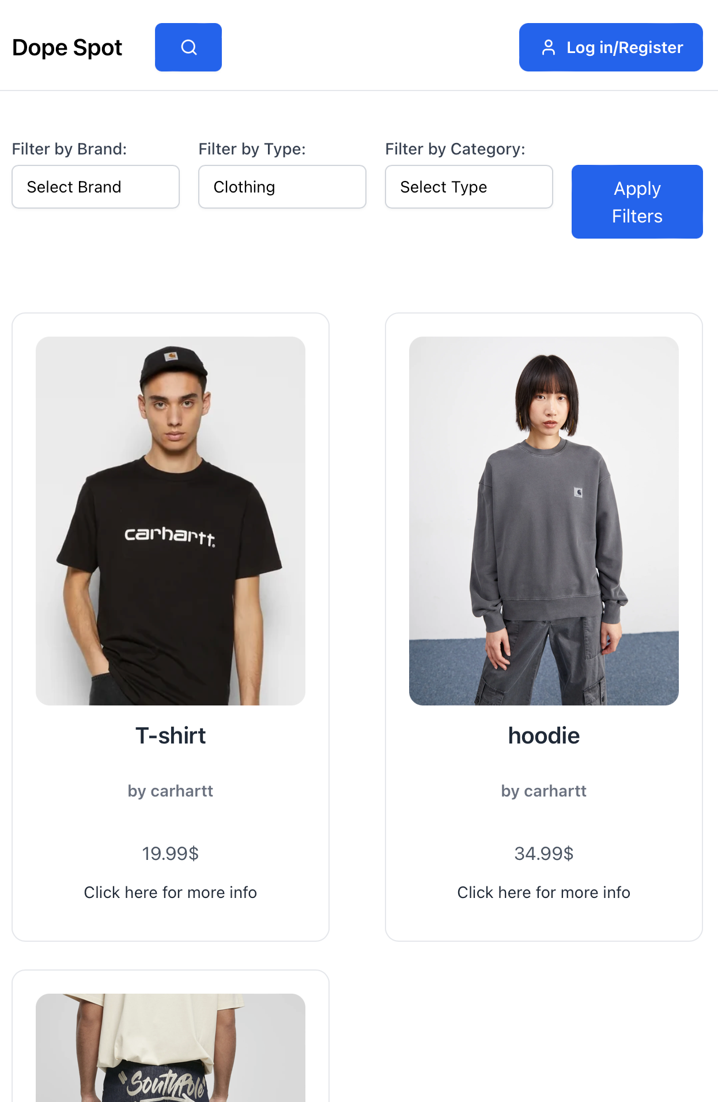

## 

## 

## 

## 

**Product detail page**

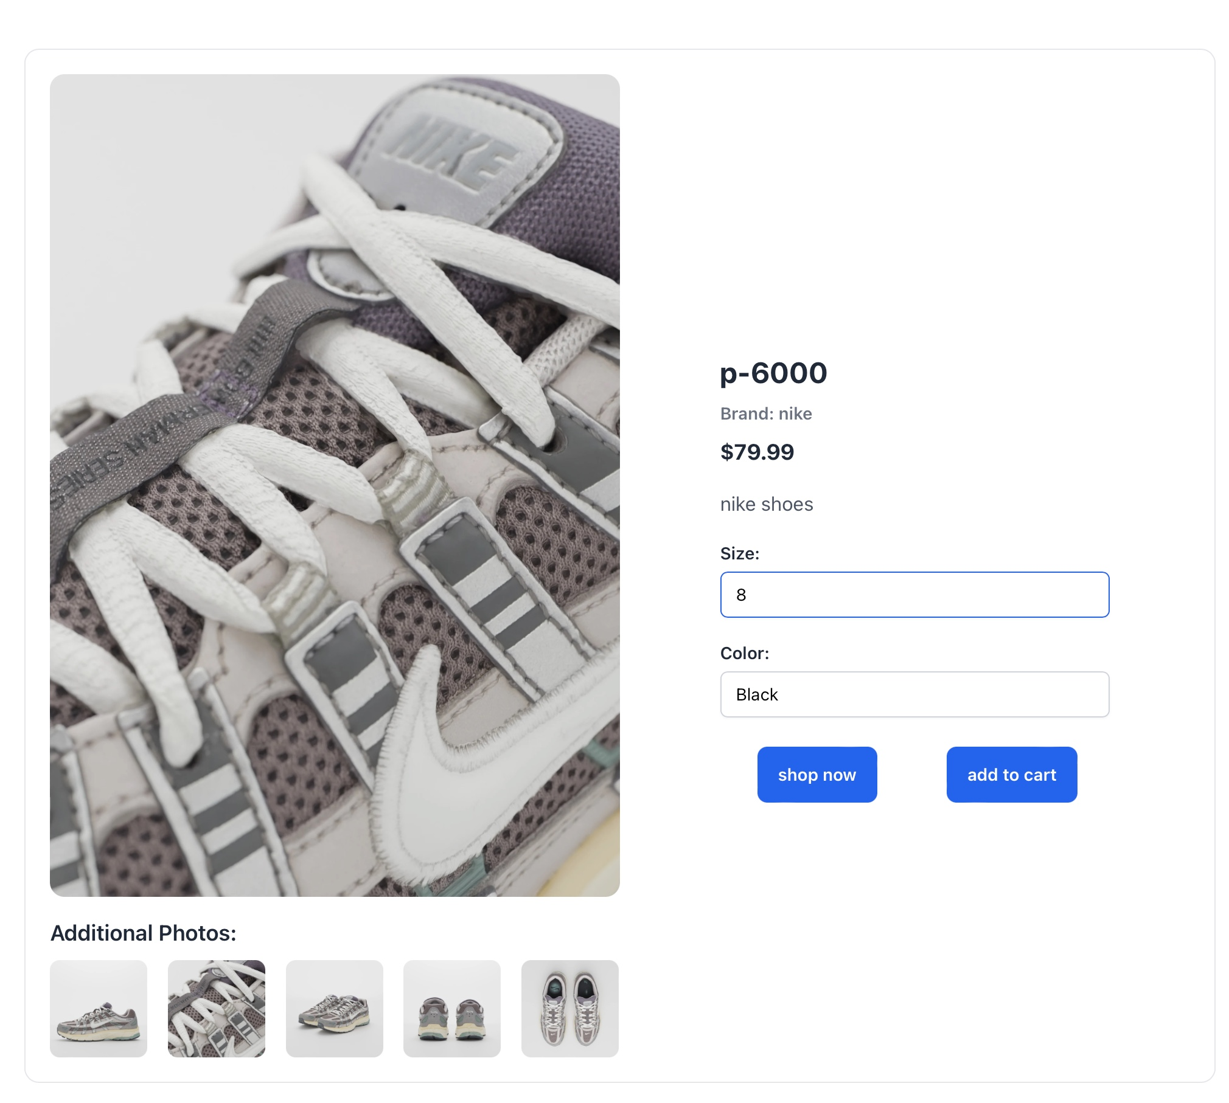

**About us and about shipping page**

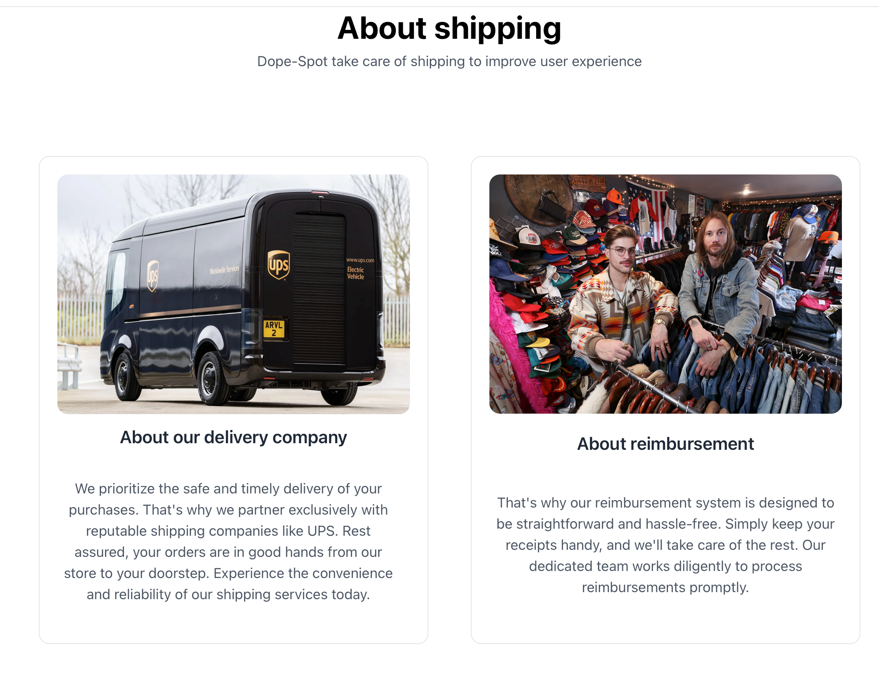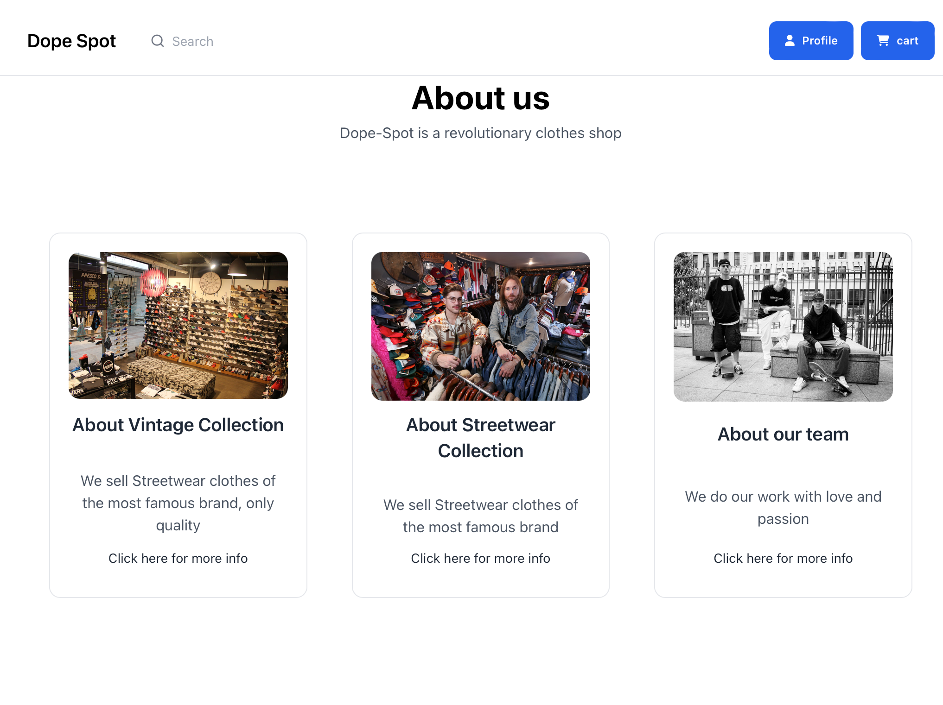

**User profile section**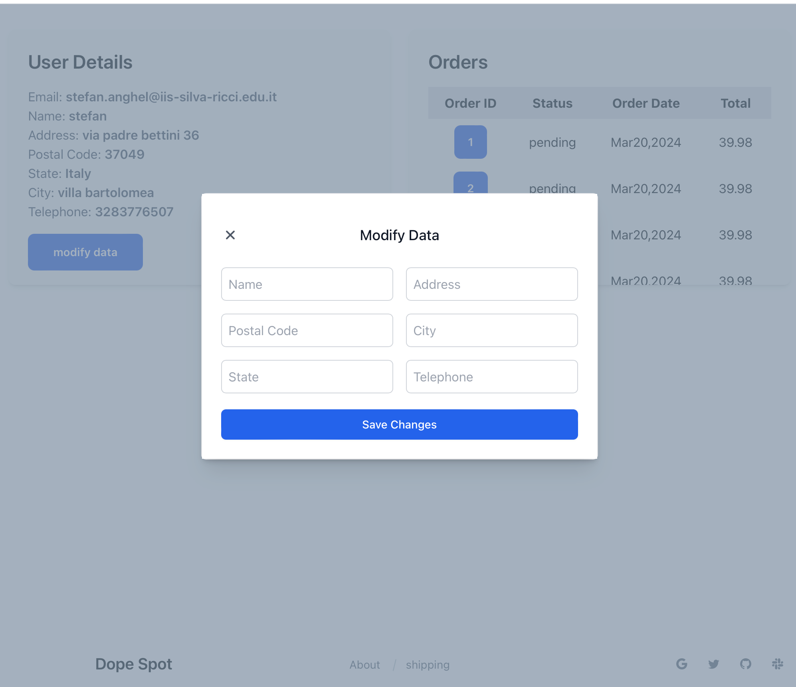

## 

## 

**Order Section**

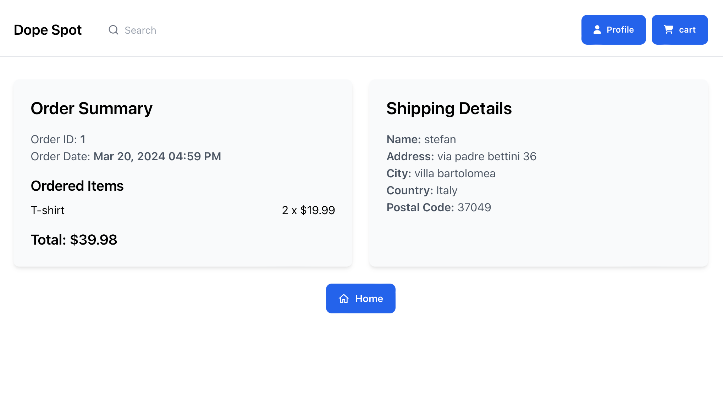

Cart Section

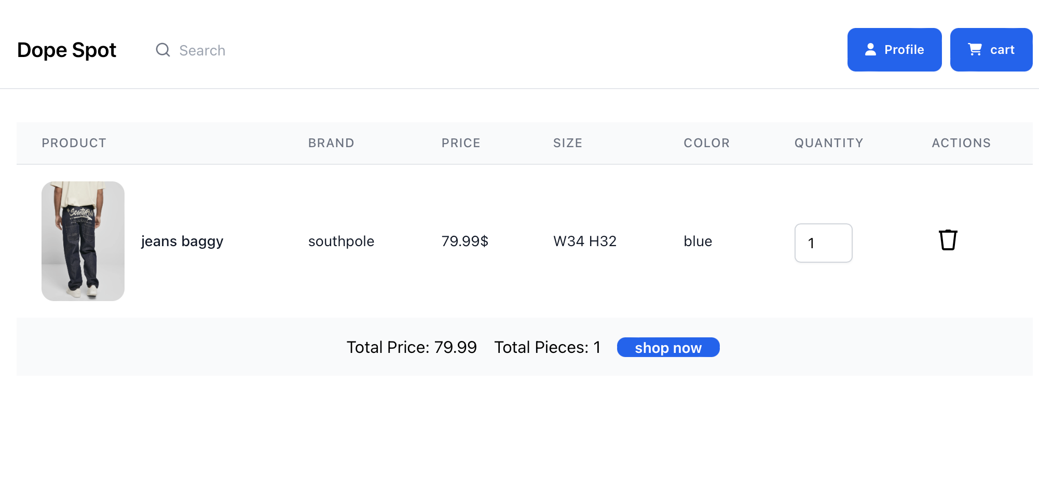

Credit card Section 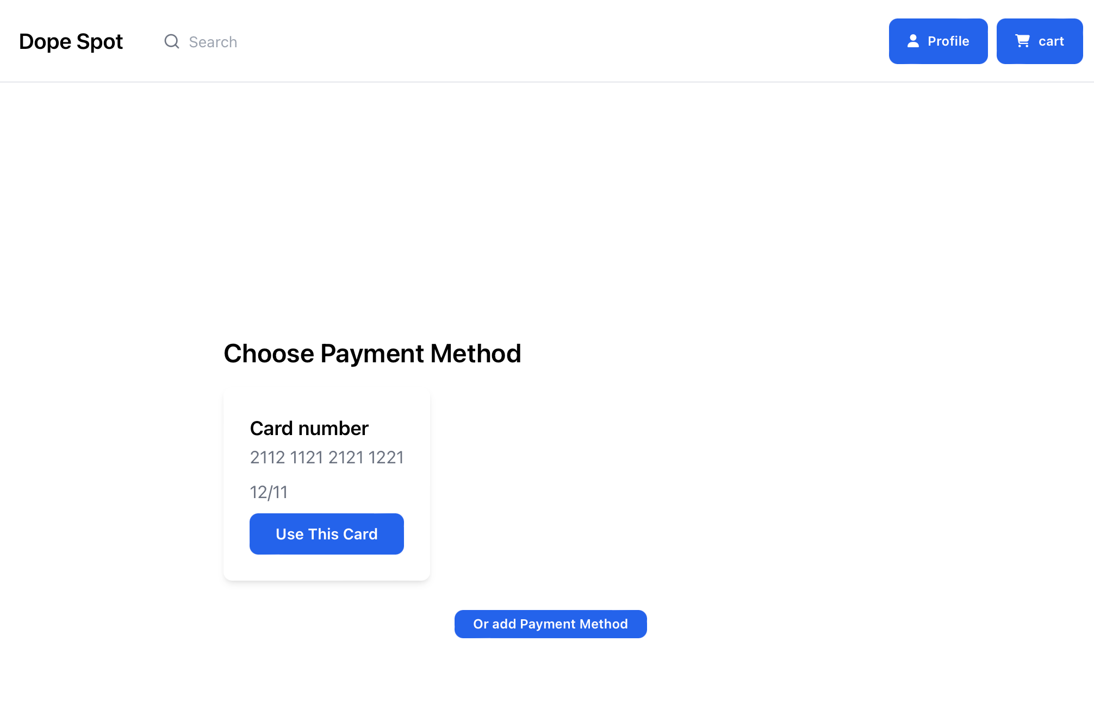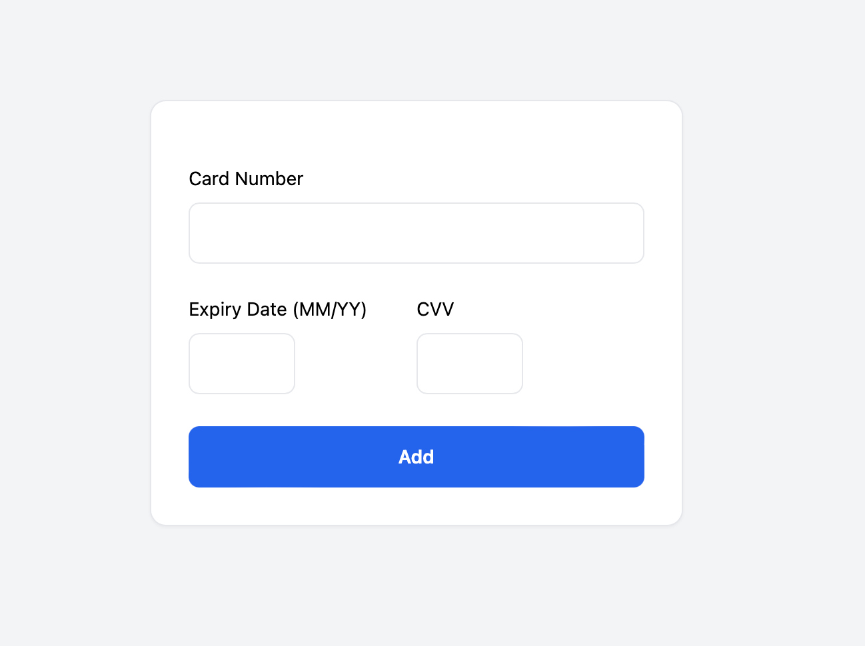

Search bar 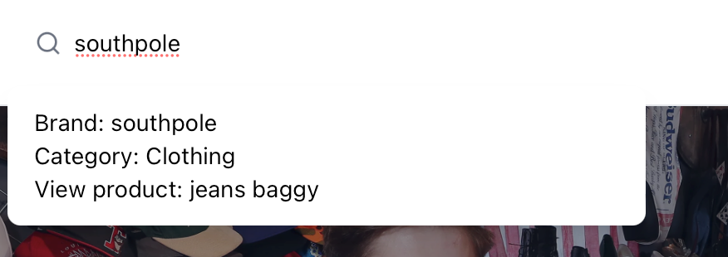

## 13. Risks and Assumptions

| Danger probability | | |
| --- | --- | --- |
| Level | Name | Description |
| 1 | unlikely | there are no known incidents of this deficiency |
| 2 | not very likely | very rare incidents |
| 3 | likely | some episodes are known in which damage followed |
| 4 | very likely | there are known damages verified for the same type of deficiency |

| Probability of damage | | |
| --- | --- | --- |
| Level | Name | Description |
| 1 | mild | reversible effects of damage quickly |
| 2 | not to be overlooked | irreversible effects |
| 3 | serious | partial disability effects, irreversible effects |
| 4 | very serious | lethal or seriously disabling effects |

Risk = Probability * Damage

| Probability |  | | | | Risk |
| --- | --- | --- | --- | --- | --- |
| 4 | 4 | 8 | 12 | 16 |  |
| 3 | 3 | 6 | 9 | 12 |
| 2 | 2 | 4 | 6 | 8 |
| 1 | 1 | 2 | 3 | 4 |
|  | 1 | 2 | 3 | 4 | Damage |

R > 8 = requires urgent corrective action

4 ≤ R ≤ 8 = corrective actions must be planned in the short term

2 ≤ R ≤ 3 = corrective actions are to be planned in the medium term

R = 1 = improvements or protection measures

| Name | Electrocution |
| --- | --- |
| Description | Contact with electrical energy resulting in injury or death. |
| Phase | Any phase |
| Probability | 1 |
| Damage | 3 |
| Risk | 3 |
| Corrective measures | - Regular maintenance of electrical system  - Use of protective equipment  - Safety training for employees  - Implementation of safety protocols and emergency procedures. |

| Name | Fire |
| --- | --- |
| Description | Uncontrolled fire causing damage to property and harm to individuals. |
| Phase | Any phase |
| Probability | 2 |
| Damage | 3 |
| Risk | 6 |
| Corrective measures | - Installation of fire detection and suppression systems  - Regular fire drills and training  - Proper storage of flammable materials  - Adherence to fire safety regulations  - Ensuring clear and accessible emergency exits  - Regular maintenance and inspection of electrical systems. |

| Name | Fall |
| --- | --- |
| Description | Injury resulting from a person falling from a height or slipping. |
| Phase | A3 |
| Probability | 3 |
| Damage | 3 |
| Risk | 9 |
| Corrective measures | - Use of fall protection equipment  - Ensuring non-slip surfaces  - Safety training for working at heights  - Regular inspection of work areas  - Installation of guardrails and safety nets in areas  - Proper lighting in work areas to avoid trips and falls  - Immediate cleanup of spills to prevent slips. |

| Name | Burnout |
| --- | --- |
| Description | Physical and mental exhaustion due to prolonged stress and overwork. |
| Phase | Any phase |
| Probability | 2 |
| Damage | 3 |
| Risk | 6 |
| Corrective measures | - Implementation of work-life balance policies  - Regular breaks and time off  - Access to mental health support  - Reasonable workload distribution  - Encouraging a supportive work environment  - Providing stress management workshops and resources  - Regular check-ins with employees to assess workload and well-being  - Promoting a healthy workplace culture that values rest and recuperation. |

| Name | Mobbing |
| --- | --- |
| Description | Psychological harassment and bullying in the workplace. |
| Phase | Any phase |
| Probability | 2 |
| Damage | 3 |
| Risk | 6 |
| Corrective measures | - Implementation of anti-bullying policies  - Regular training on respectful workplace behavior  - Fostering a positive and inclusive work culture  - Ensuring confidentiality and protection for individuals who report mobbing  - Regular team-building activities to promote positive interactions  - Continuous monitoring and addressing of workplace dynamics to prevent mobbing. |

## 14.WBS

| WBS | Nome attività |
| --- | --- |
| 0 | DOPE-SPOT |
| 1 | Planning |
| 1.1 | abstract |
| 1.2 | make pid |
| 1.3 | make wbs and pbs |
| 1.4 | make gant and pert |

| WBS | Nome attività |
| --- | --- |
| 2 | Project design |
| 2.1 | Market analysis |
| 2.1.1 | Analyze market and competitor |
| 2.1.2 | Research target |
| 2.2 | Website design and layout |
| 2.2.1 | home page design |
| 2.2.2 | User detail page design |
| 2.2.3 | Product category pages design |
| 2.2.4 | Product detail pages design |
| 2.2.5 | Checkout process design |
| 2.3 | Database development |
| 2.3.1 | E/R diagram creation |
| 2.3.2 | Logic scheme development |
| 2.3.3 | Database table creation |
| 2.3.4 | Establishing relationship between table |

| WBS | Nome attività |
| --- | --- |
| 3 | Realization |
| 3.1 | Website development |
| 3.1.1 | Domain register and host setting |
| 3.1.2 | Frontend Development |
| 3.1.2.1 | HTML and CSS coding |
| 3.1.2.2 | Make a responsive design |
| 3.1.3 | Backend development |
| 3.1.3.1 | E-commerce functionality implementation |
| 3.1.3.2 | User account management |
| 3.1.3.3 | Payment Gateway Integration |
| 3.1.4 | Customer Service |
| 3.1.4.1 | Customer support setup |
| 3.1.4.2 | Return and exchange policy creation |
| 3.1.4.3 | FAQ section development |
| 3.1.4.4 | Order tracking functionality implementation |
| 3.1.5 | Testing and debugging |
| 3.1.5.1 | Cross-browser Testing |
| 3.1.5.2 | Functionality Testing |
| 3.1.5.3 | Performance Testing |
| 3.2 | Product Management |
| 3.2.1 | Inventory management setup |
| 3.2.2 | Product catalog creation |
| 3.2.3 | Product photography and editing |
| 3.2.4 | Pricing strategy development |
| 3.2.5 | Product description and details |

| WBS | Nome attività |
| --- | --- |
| 4 | Deployment |
| 4.1 | Legal and Compliance |
| 4.1.2 | Terms and conditions creation |
| 4.1.3 | Privacy policy development |
| 4.2 | Marketing and Promotion |
| 4.2.1 | Social media marketing strategy |
| 4.2.2 | Influencer collaborations |
| 4.2.3 | Paid advertising campaigns |
| 4.3 | Launch |

| WBS | Nome attività |
| --- | --- |
| 5 | Final review |
| 5.1 | Marketing campaign launch |

# **Project Management Appendices: Detailed Explanations**

## **Appendix 1: Project Roles and Responsibilities**

* **Project Manager (PM):**
  + Acts as the general manager of the "Dope Spot" project, overseeing all aspects of its development and operation.
  + Coordinates all activities and resources involved in the project to ensure timely completion and adherence to objectives.
  + Serves as the main point of contact for stakeholders, communicating project progress, addressing concerns, and managing expectations.
* **Marketing Manager:**
  + Defines and implements marketing and promotion strategies to increase brand awareness and drive sales.
  + Collaborates with influencers and manages advertising campaigns on social media platforms to reach target audiences effectively.
  + Analyzes market trends and consumer behavior to refine marketing strategies and maximize ROI.
* **Graphic Designer:**
  + Designs the user interface and user experience of the "Dope Spot" website, focusing on aesthetics, usability, and functionality.
  + Creates wireframes, mockups, and prototypes to visualize and communicate design concepts and ideas.
  + Collaborates with developers and stakeholders to implement design solutions that enhance the overall user experience and achieve business goals.
* **Frontend Developer:**
  + Implements the visual and interactive elements of the "Dope Spot" website, translating design concepts into code.
  + Develops user-facing features and functionalities using HTML, CSS, and JavaScript, ensuring compatibility across browsers and devices.
  + Collaborates with designers and backend developers to integrate frontend components seamlessly with backend systems and databases.
* **Backend Developer:**
  + Develops the server-side logic and functionality of the "Dope Spot" website, including database interactions and business logic.
  + Designs and implements APIs and web services to enable communication between the frontend and backend systems.
  + Ensures the security, scalability, and performance of backend systems, optimizing code and infrastructure as needed.
* **Project Designer:** 
  + Creates visual aids such as flowcharts, sitemaps, and user journey maps to communicate the project plan and user experience.
  + Collaborates with designers and developers to ensure clear communication of project goals and functionalities.
* **Business Analyst:** 
  + Analyzes business needs and translates them into project requirements.
  + Creates user stories and functional specifications to define the functionalities of the Dope Spot platform.
  + Works with stakeholders to identify and prioritize project features.
* **Administration Manager:** 
  + Provides administrative support to the project team, handling tasks such as scheduling meetings, managing documentation, and travel arrangements.
* **Quality Manager:** 
  + Establishing testing procedures and ensuring their implementation.
  + Monitors defect tracking and resolution processes. (Consider if a dedicated role is needed based on project size and complexity)

## **Appendix 2: High-Level Project Plan**

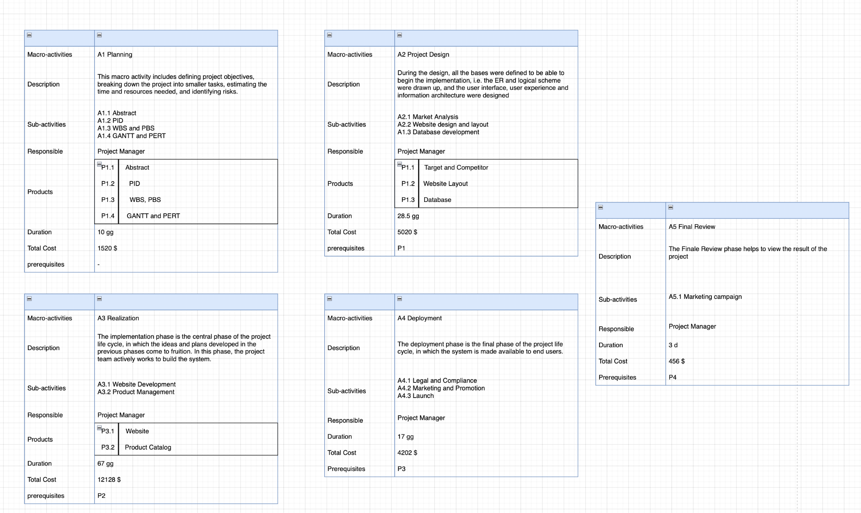

## **Appendix 3:Gantt and Pert**

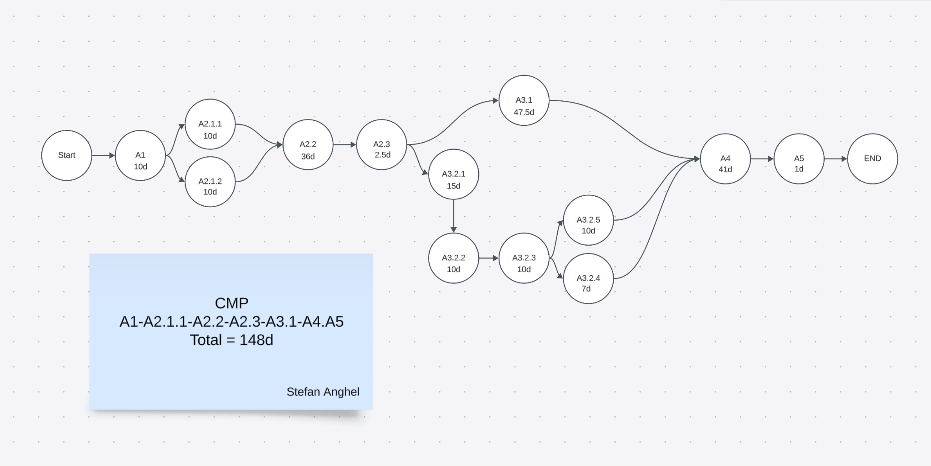

## **Appendix 4: Project Costs**

| WBS | Phase | Internal Cost | General Cost | SW | HW | DB | Advice | Marketing | TOT |
| --- | --- | --- | --- | --- | --- | --- | --- | --- | --- |
| A1 | Planning | 1520 | 130 | 1500 | 0 | 130 | 100 | 0 | 3380 |
| A2 | Project Design | 5020 | 325 | 800 | 1500 | 325 | 1500 | 0 | 9470 |
| A3 | Realization | 12168 | 689 | 800 | 3200 | 689 | 300 | 0 | 17077 |
| A4 | Deployment | 4032 | 500 | 900 | 700 | 500 | 0 | 3000 | 6132 |
| A5 | Final Review | 456 | 50 | 0 | 120 | 50 | 0 | 4000 | 626 |

## **Appendix 5: gap analysis**

| Phase | Planning |
| --- | --- |
| Objectives | Define project objectives and create a project team. |
| Plan | 10 working days. |
| Actual | 10 working days. |
| Deviation | none |

| Phase | Project Design |
| --- | --- |
| Objectives | Define project requirements, deadlines, and necessary resources. |
| Plan | 28.5 working days. |
| Actual | 28.5 working days. |
| Deviation | none. |

| Phase | Realization |
| --- | --- |
| Objectives | Design user interface, functionalities, database, Website development and Product management. |
| Plan | 67 working days. |
| Actual | 78 working days. |
| Causes | * Errors with xampp * problems with the laravel version change, * Too complex user interface * poorly structured database |
| Preventive actions | * Conduct thorough testing and debugging of XAMPP setup before project initiation * Implement a detailed plan for managing Laravel version changes, including testing and compatibility checks. * Simplify the user interface design to reduce complexity. * Establish a clear database structure and adhere to best practices during development to ensure proper organization and efficiency. |
| Deviation | 11 working days |

| Phase | Deployment |
| --- | --- |
| Objectives |  |
| Plan | 41 working days. |
| Actual | 45 working days. |
| Causes | * Legal Problem |
| Preventive actions | * Protect user privacy |
| Deviation | 4 working days |

| Phase | Final Review |
| --- | --- |
| Objectives | Website launch |
| Plan | 3 working days. |
| Actual | 3 working days. |
| Deviation | none. |

## **Appendix 6: Product Software Evaluation**

**What is PSLOC?**

Physical Source Lines of Code (PSLOC) is a metric used to measure the size of a software codebase by counting the number of physical lines of code. It includes all lines that make up the source files, such as:

* Blank lines: Lines without any code or comments.
* Comment lines: Lines containing only comments.
* Code lines: Lines that contain actual code, excluding blank and comment lines.

PSLOC is often used in software engineering to estimate the complexity and effort required for maintaining or developing software. It helps in understanding the scale of the project and is useful for various analyses like productivity, quality, and cost estimation.

**My Project's PSLOC Breakdown**

I provided two separate pSLOC summaries for different parts of my project.

Here's an analysis and reference to your project's real code:

-------------------------------------------------------------------------------------------------------------------------

Language files blank comment code Lsloc % Lsloc

-------------------------------------------------------------------------------------------------------------------------

Blade 14 106 76 770 30% 539

Vuejs Component 9 73 62 632 30% 442

PHP 19 226 134 730 30% 511

JavaScript 1 1 0 16 30% 11

CSS 1 1 0 7 40% 3

SCSS 1 0 0 1 40% 1

-------------------------------------------------------------------------------------------------------------------------

SUM: 44 407 272 2156 1507

-------------------------------------------------------------------------------------------------------------------------

**Comprehensive Project View**

1. Blade : Used for creating the view layer in a Laravel application.
2. Vue.js Components: Front-end components managed within the Laravel framework, enhancing interactivity.
3. JavaScript, CSS, SCSS: Supporting front-end technologies for styling and functionality.
4. PHP: Back-end logic and server-side scripting.

**Generated Code by Laravel and Node**

In addition to the manually written code, you've mentioned that other parts of your project are generated by Laravel and npm. This typically includes:

* Laravel: Automatically generates code for web applications such as controllers, models, views, and migrations.
* npm: Manages JavaScript dependencies and can generate boilerplate code, manage scripts, and handle front-end build processes.

Language files blank comment code

---------------------------------------------------------------------------------------

JavaScript 11291 160421 359740 1533815

PHP 7633 123055 263982 538856

JSON 1218 82 0 300228

TypeScript 3965 12037 94304 169405

Markdown 1360 53437 611 138987

YAML 121 148 42 104235

CSS 45 6518 429 19267

SVG 2055 0 15 10842

SCSS 34 590 143 8729

LESS 32 586 116 8697

XSD 17 113 48 7154

Text 31 963 0 2121

Blade 49 284 151 2026

reStructuredText 37 1103 1402 1293

Bourne Shell 7 180 121 877

Vuejs Component 9 73 62 632

Bourne Again Shell 5 116 60 573

Windows Module Definition 5 83 0 451

HTML 10 27 4 286

XML 10 8 9 235

Dockerfile 5 48 2 216

INI 12 40 4 165

make 6 34 7 71

AppleScript 1 11 23 61

Python 1 70 155 43

zsh 1 10 31 41

Nix 1 1 0 19

Fish Shell 1 7 6 16

DOS Batch 3 0 0 8

SQL 1 0 0 2

CoffeeScript 1 1 0 0

Fortran 77 4 0 29 0

---------------------------------------------------------------------------------------

SUM: 27971 360046 721496 2849351

---------------------------------------------------------------------------------------